Task on VPC -1

- Create VPC with 2 private and 2 public subnets.
- Step 1 — Create the VPC
AWS Console → VPC → Your VPCs → Create VPC
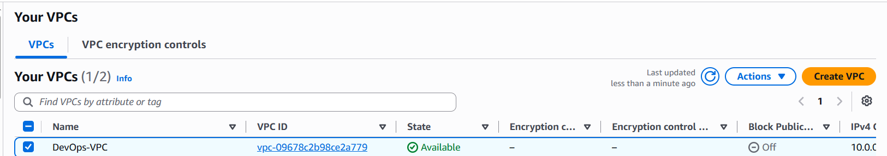
— Create 4 subnets
VPC → Subnets → Create subnets

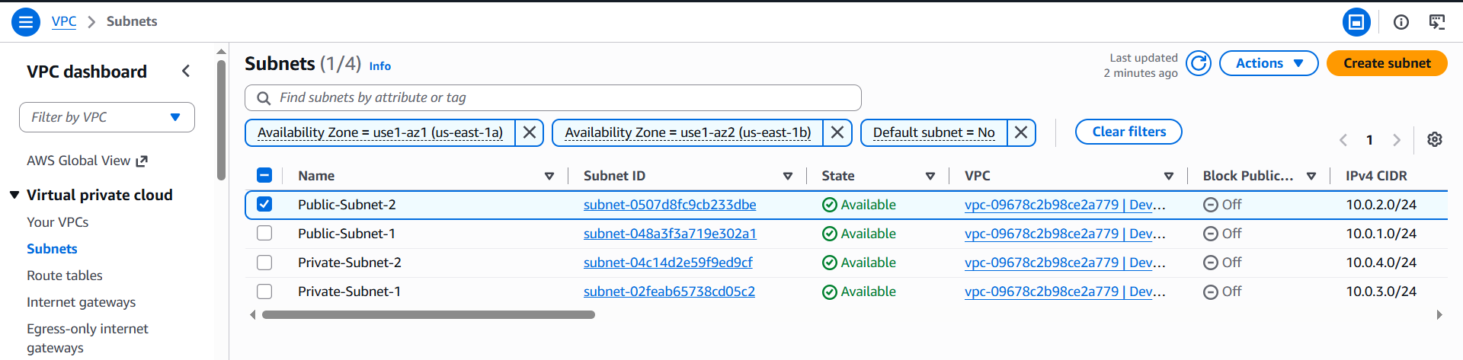

2. Enable DNS Hostname in VPC.
— Enable DNS Hostnames
Actions → Edit VPC settings
DNS resolution ✓
DNS hostnames ✓
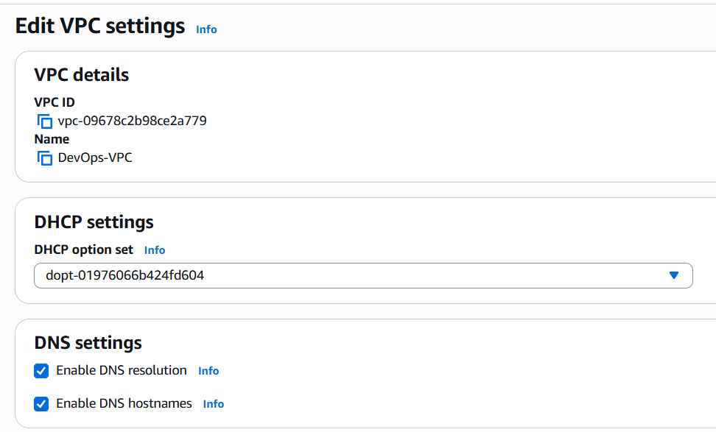
3. Enable Auto Assign Public IP in 2 public subnets.
— Enable Auto Assign Public IP
VPC → Subnets
Select:
Public-Subnet-1
Then:
Actions → Edit subnet settings
Enable:
Enable auto-assign public IPv4 address ✓
We will do the same for public-subnet-2
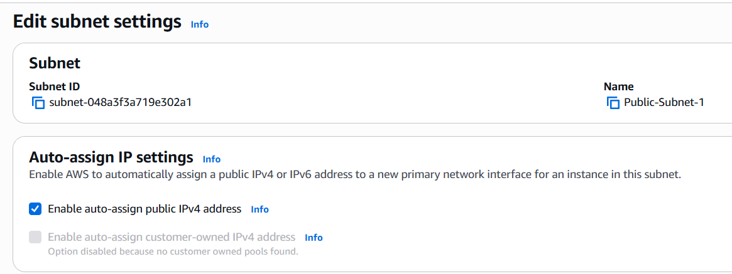
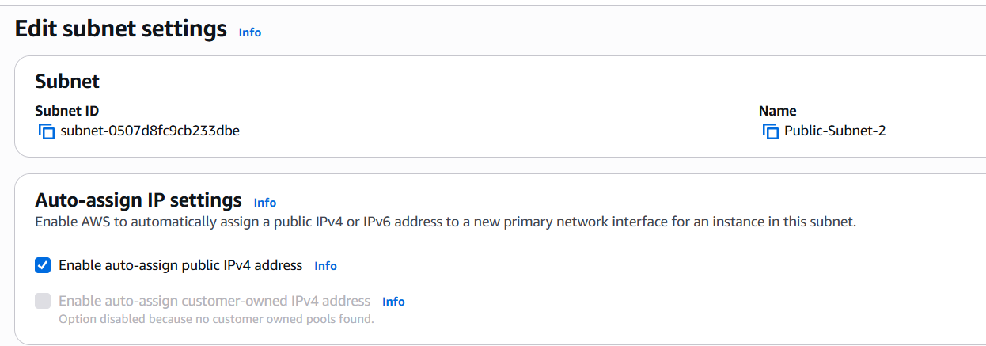

4. Add 2 private subnets in private route table.
Create Private Route Table
Go to: VPC → Route Tables → Create route table
Name: Private-RT
VPC: DevOps-VPC
Create.
Add private subnets
Open:
Private-RT
Go to:
Subnet associations → Edit subnet associations
Select:
Private-Subnet-1
Private-Subnet-2
Save.
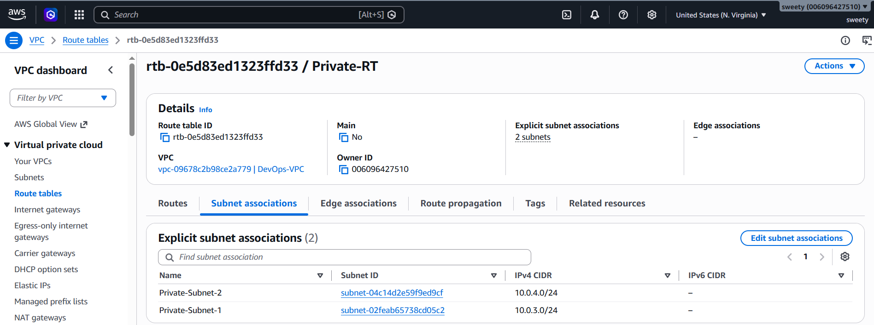

5. Add 2 public subnets in public route table.
Create Public Route Table
Go to: VPC → Route Tables → Create route table
Name: Public-RT
VPC: DevOps-VPC
Create.
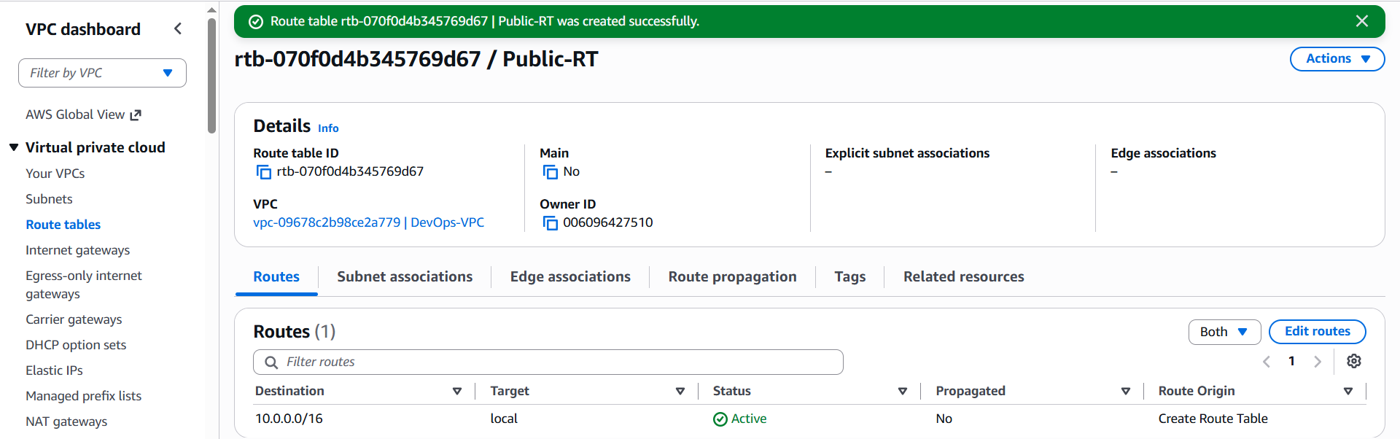

Add Public subnets to Public-RT
Open: Public-RT
Go to: Subnet associations → Edit subnet associations
Select: Public-Subnet-1
Public-Subnet-2
Save associations
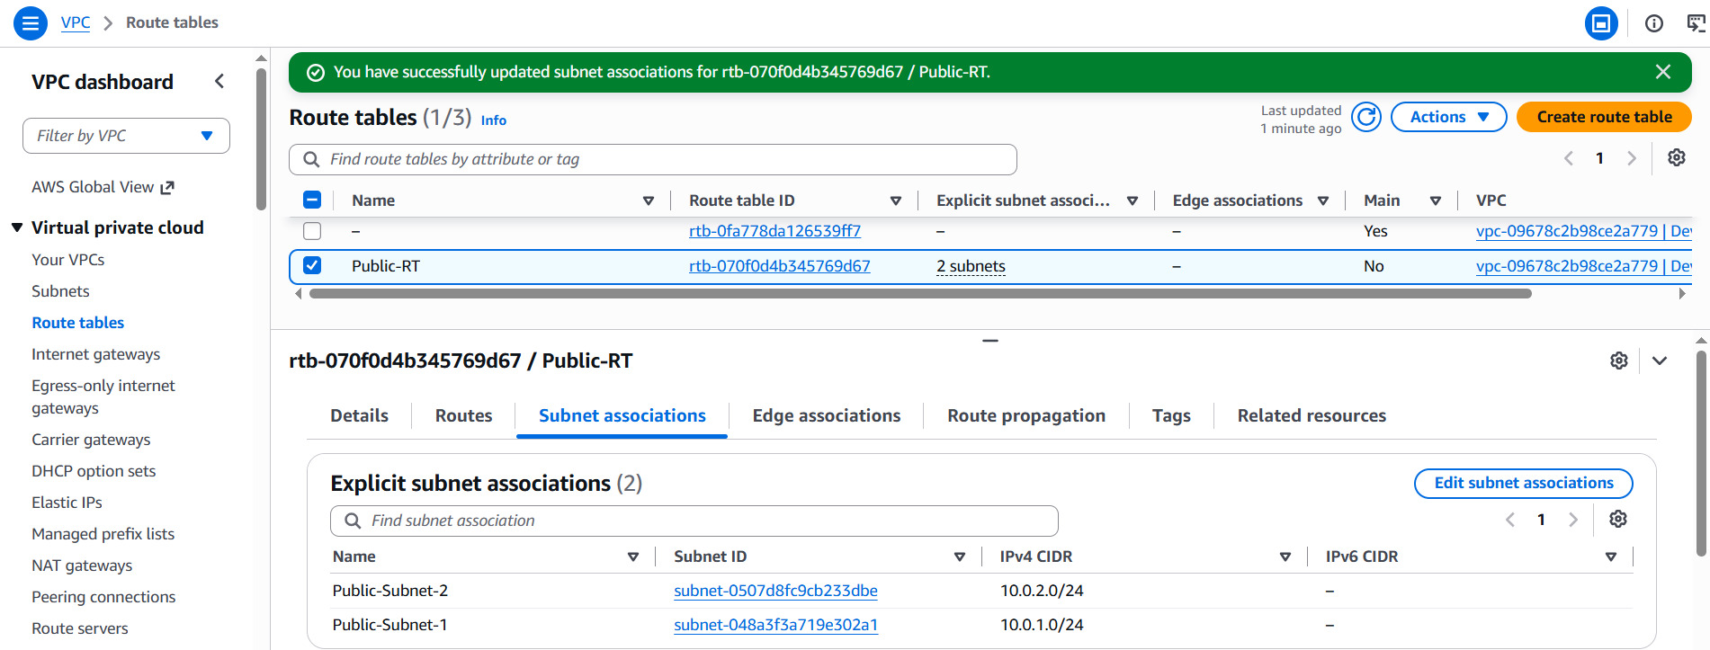

6. Public route table will have the routes to internet and local.
Step 1: Create Internet Gateway
Go to: VPC → Internet Gateways
Click: Create internet gateway
Name: DevOps-IGW
Create it.
Step 2: Attach Internet Gateway to VPC
Select: DevOps-IGW
Click: Actions → Attach to a VPC
Select: DevOps-VPC
Click: Attach internet gateway
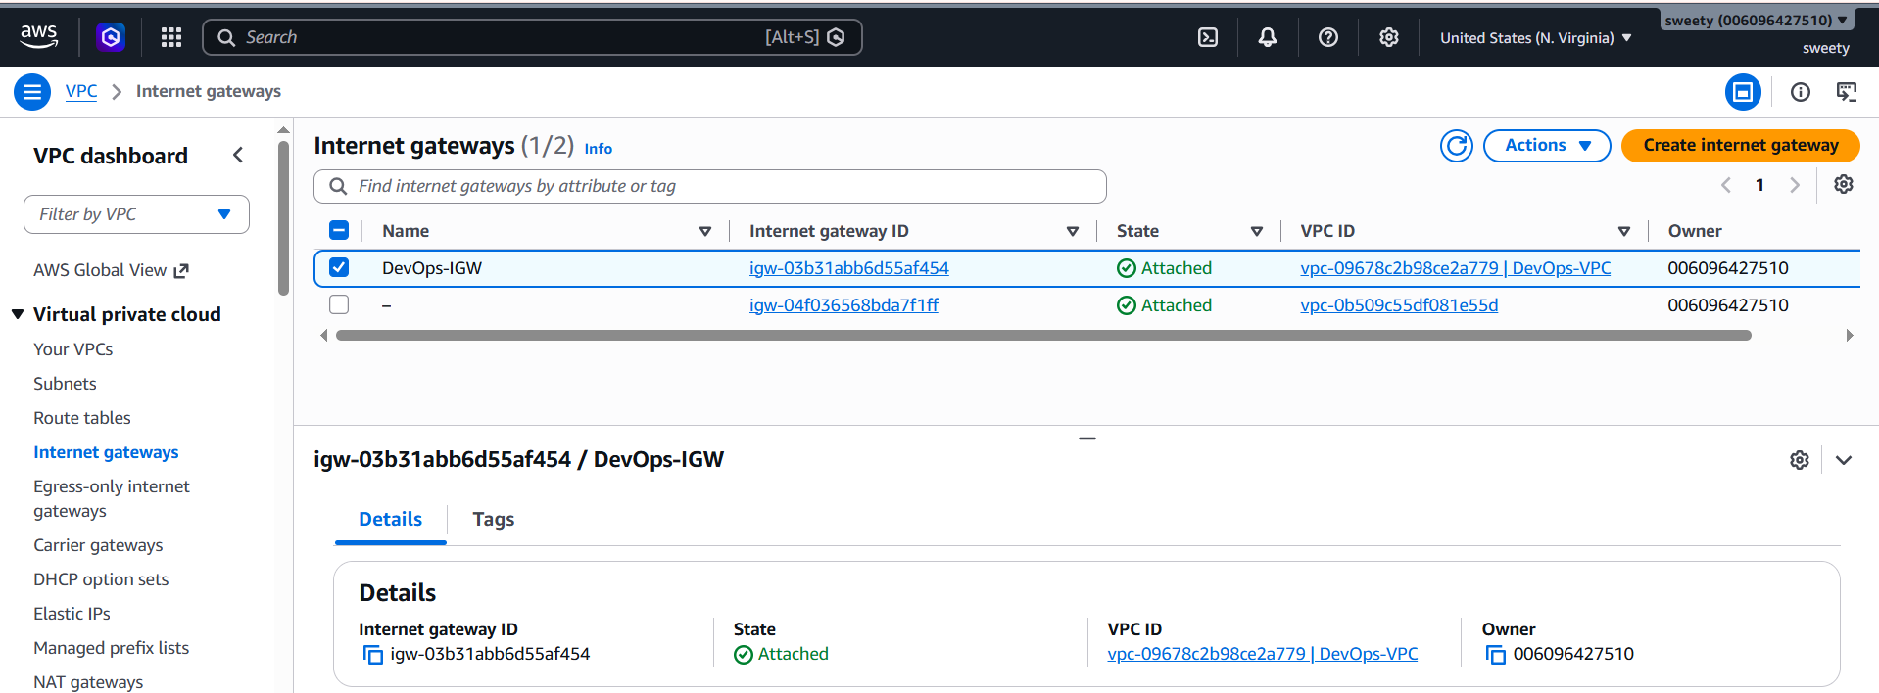
Step 3: Add route
Go to: VPC → Route Tables → Public-RT
Go to: Routes → Edit routes
Destination Target
10.0.0.0/16 local
Add: Destination: 0.0.0.0/0
Target: Internet Gateway → DevOps-IGW
Save changes.
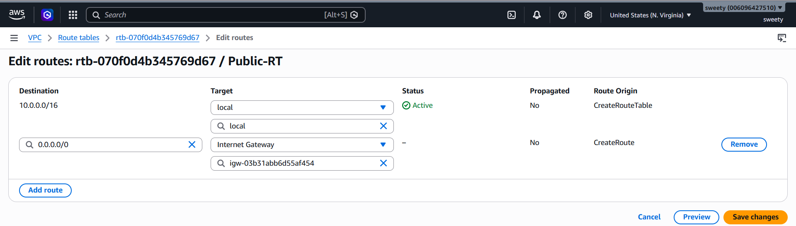

7. Create EC2 in public subnet with t2.micro and install PHP.
- Created the Ec2 instance in public subnet with t3.micro
Go to:
Network settings
Click:
Edit
Set:
VPC: DevOps-VPC
Subnet: Public-Subnet-1
Auto-assign Public IP:
Enable
- t2.micro was unavailable in the selected AWS region/account, so t3.micro was used as an equivalent free- tier eligible/small instance for he practical.
- Installed PHP successfully.

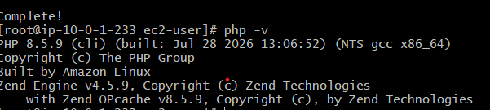
- Stared the service

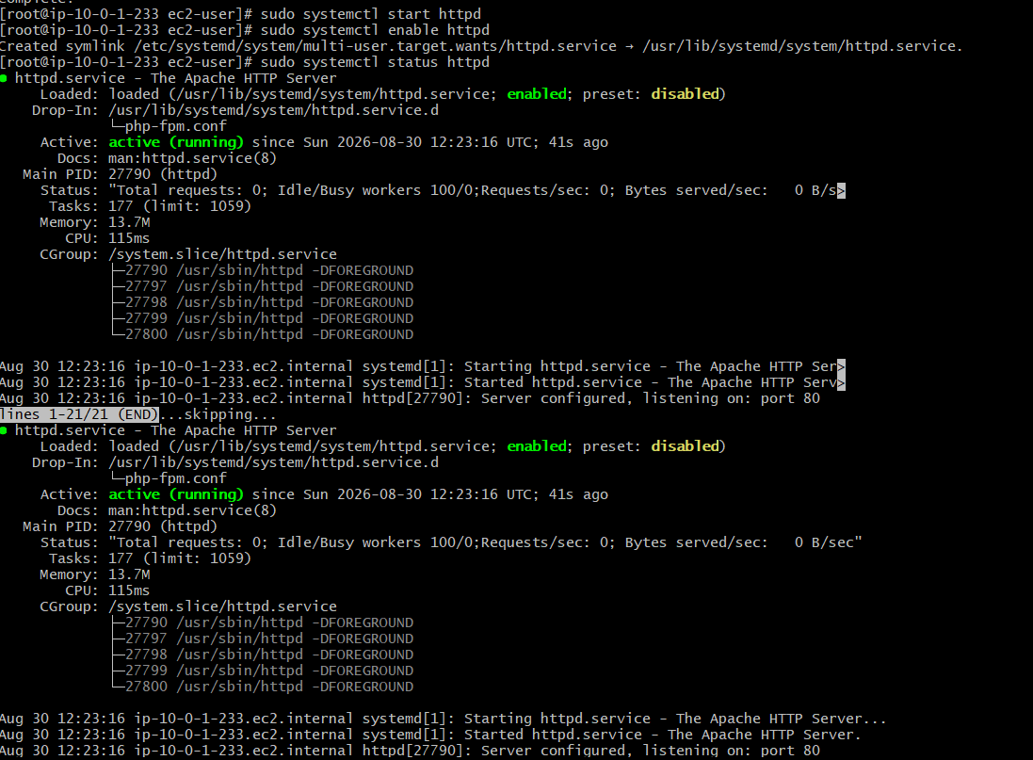
- Created the PHP test page

sudo vi /var/www/html/index.php

edit:
<?php
phpinfo();
?>

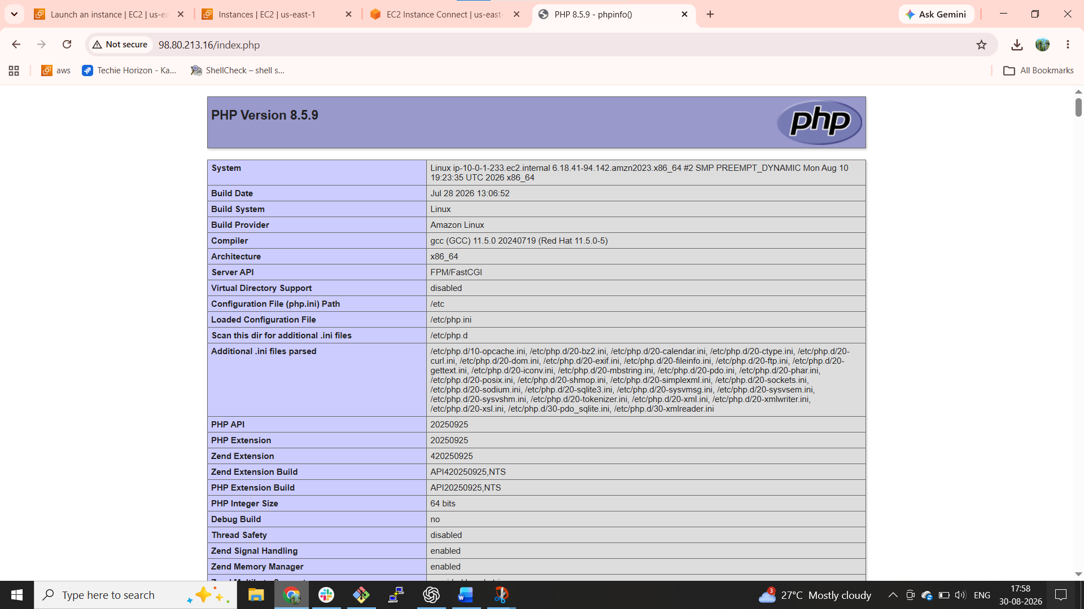

8. Configure NAT gateway in public subnet and connect to private instance.
Step 1: Allocate Elastic IP
VPC → Elastic Ips
Allocate Elastic IP address – allocate
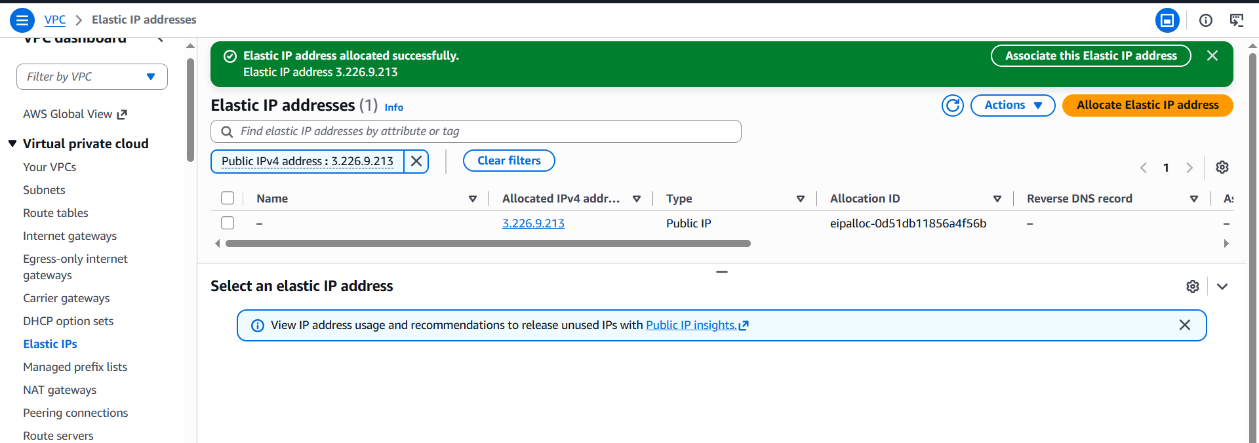
Step 2: Create NAT Gateway
VPC → NAT Gateways
Create NAT gateway
Name: DevOps-NAT-GW
Subnet: Public-Subnet-1
Connectivity type: Public
Elastic IP: eipalloc-0d51db11856a4f56b

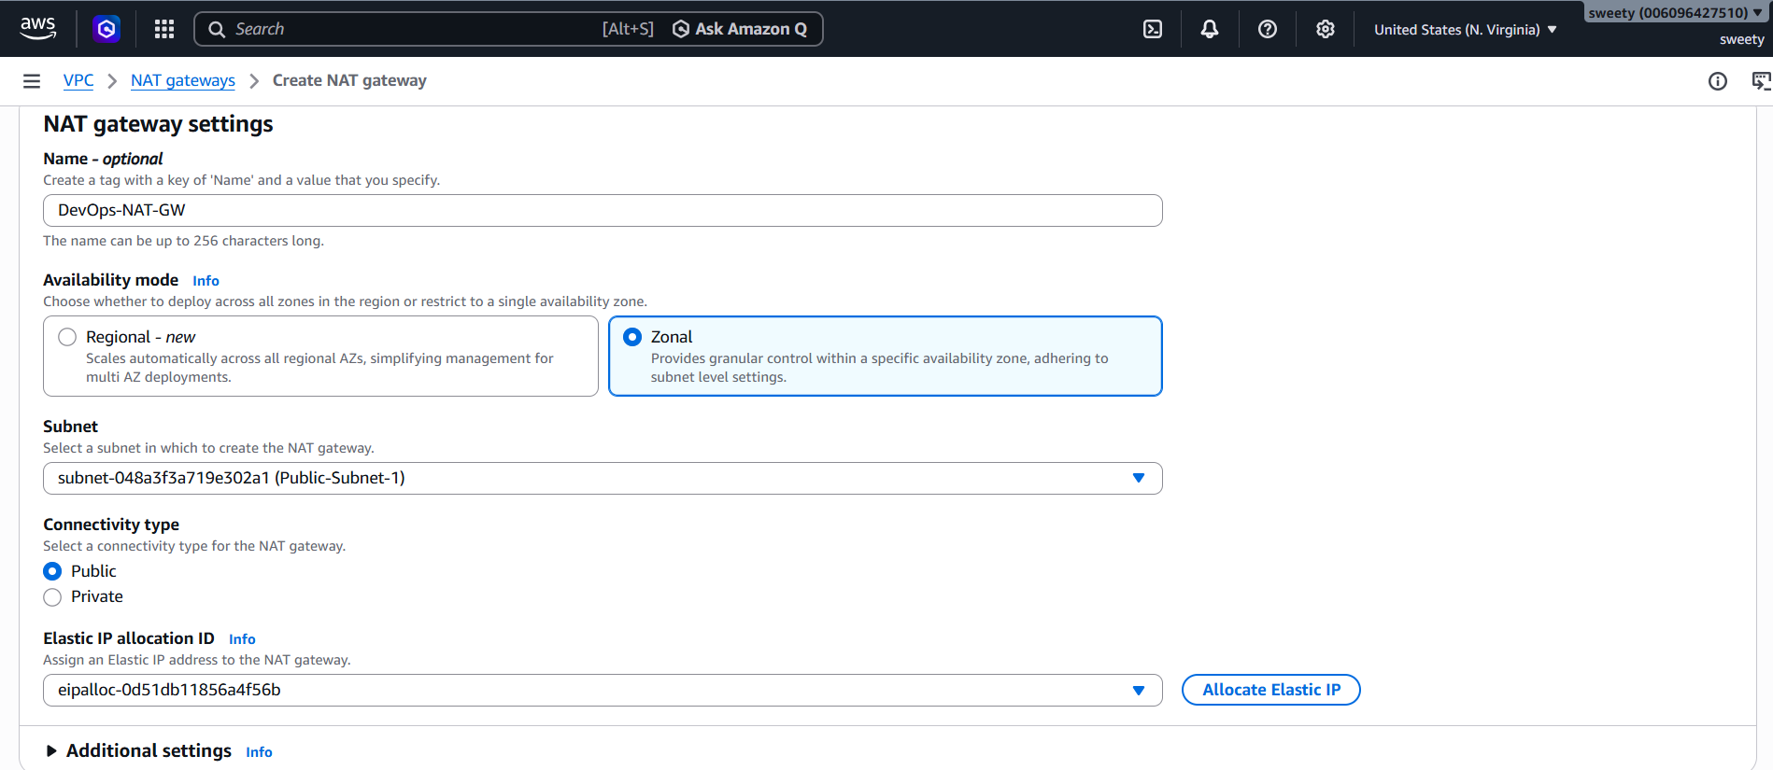
Step 3: Add NAT route to Private Route Table
VPC → Route Tables
Open: Private-RT
Goto: Routes → Edit routes
Destination:
0.0.0.0/0
Target:
NAT Gateway → DevOps-NAT-GW
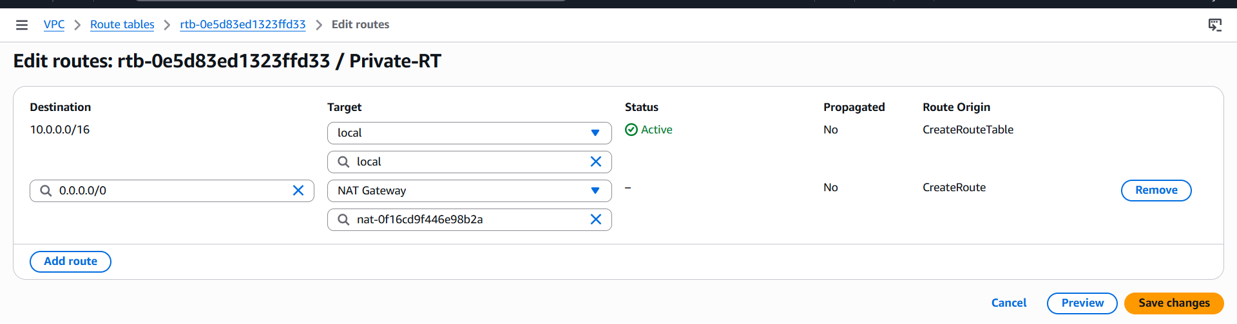
Now created the EC2 sucessfully
VPC: DevOps-VPC
Subnet: Private-Subnet-1
Auto-assign Public IP: Disable
Connect to Private EC2
Because the private EC2 has no public IP, you cannot directly do:
ssh ec2-user@10.0.3.90
first run public IP and connect through SSH
$ ssh -A -i devops-key.pem ec2-user@100.27.35.184
and then inside
[ec2-user@ip-10-0-1-233 ~]$ ssh ec2-user@10.0.3.90
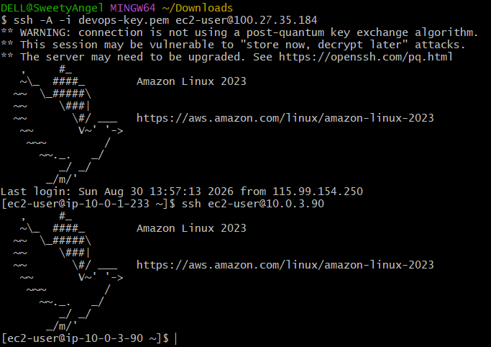

9. Install Apache Tomcat in private EC2 and deploy a sample app.
First update packages:
sudo dnf update -y
Install Java:
sudo dnf install java-17-amazon-corretto -y
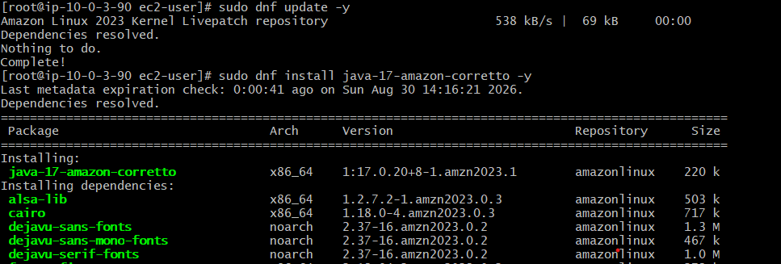
Check:
java -version
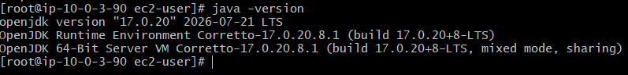
Download Tomcat
You can download a current Tomcat 10 release from the Apache Tomcat website.
For example, after obtaining the current tarball URL:
cd /opt
Download it:
sudo wget https://dlcdn.apache.org/tomcat/tomcat-9/v9.0.121/bin/apache-tomcat-9.0.121.tar.gz
Extract:
sudo tar -xzf https://dlcdn.apache.org/tomcat/tomcat-9/v9.0.121/bin/apache-tomcat-9.0.121.tar.gz
tar.gz
Rename:
sudo mv apache-tomcat-* tomcat
Give permissions:
sudo chown -R ec2-user:ec2-user /opt/tomcat
Start Tomcat
Go to:
cd /opt/tomcat/bin
Start:
./startup.sh
Check:
ps -ef | grep tomcat
You can also check:
curl http://localhost:8080
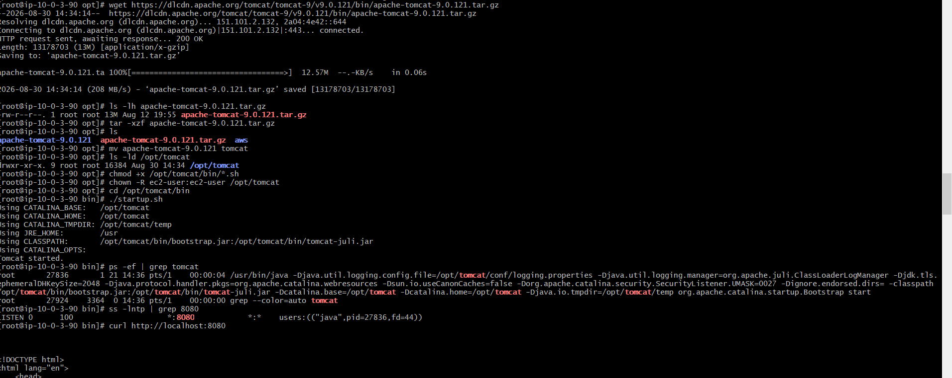

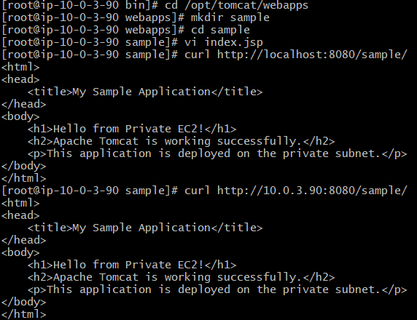

10. Configure VPC flow logs and store the logs in S3 and CloudWatch
- VPC Flow Logs → S3
- VPC Flow Logs → CloudWatch Logs
Step 1: Create an S3 bucket
Open the AWS Console and search for:
S3
Click S3.
Then click:
Create bucket
Bucket name
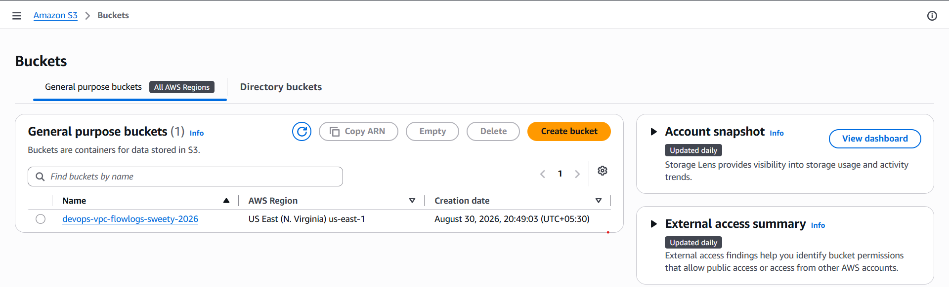
Step 2: Create the VPC Flow Log
Now go to:
VPC → Your VPCs

Then created successfully the s3 flowlogs

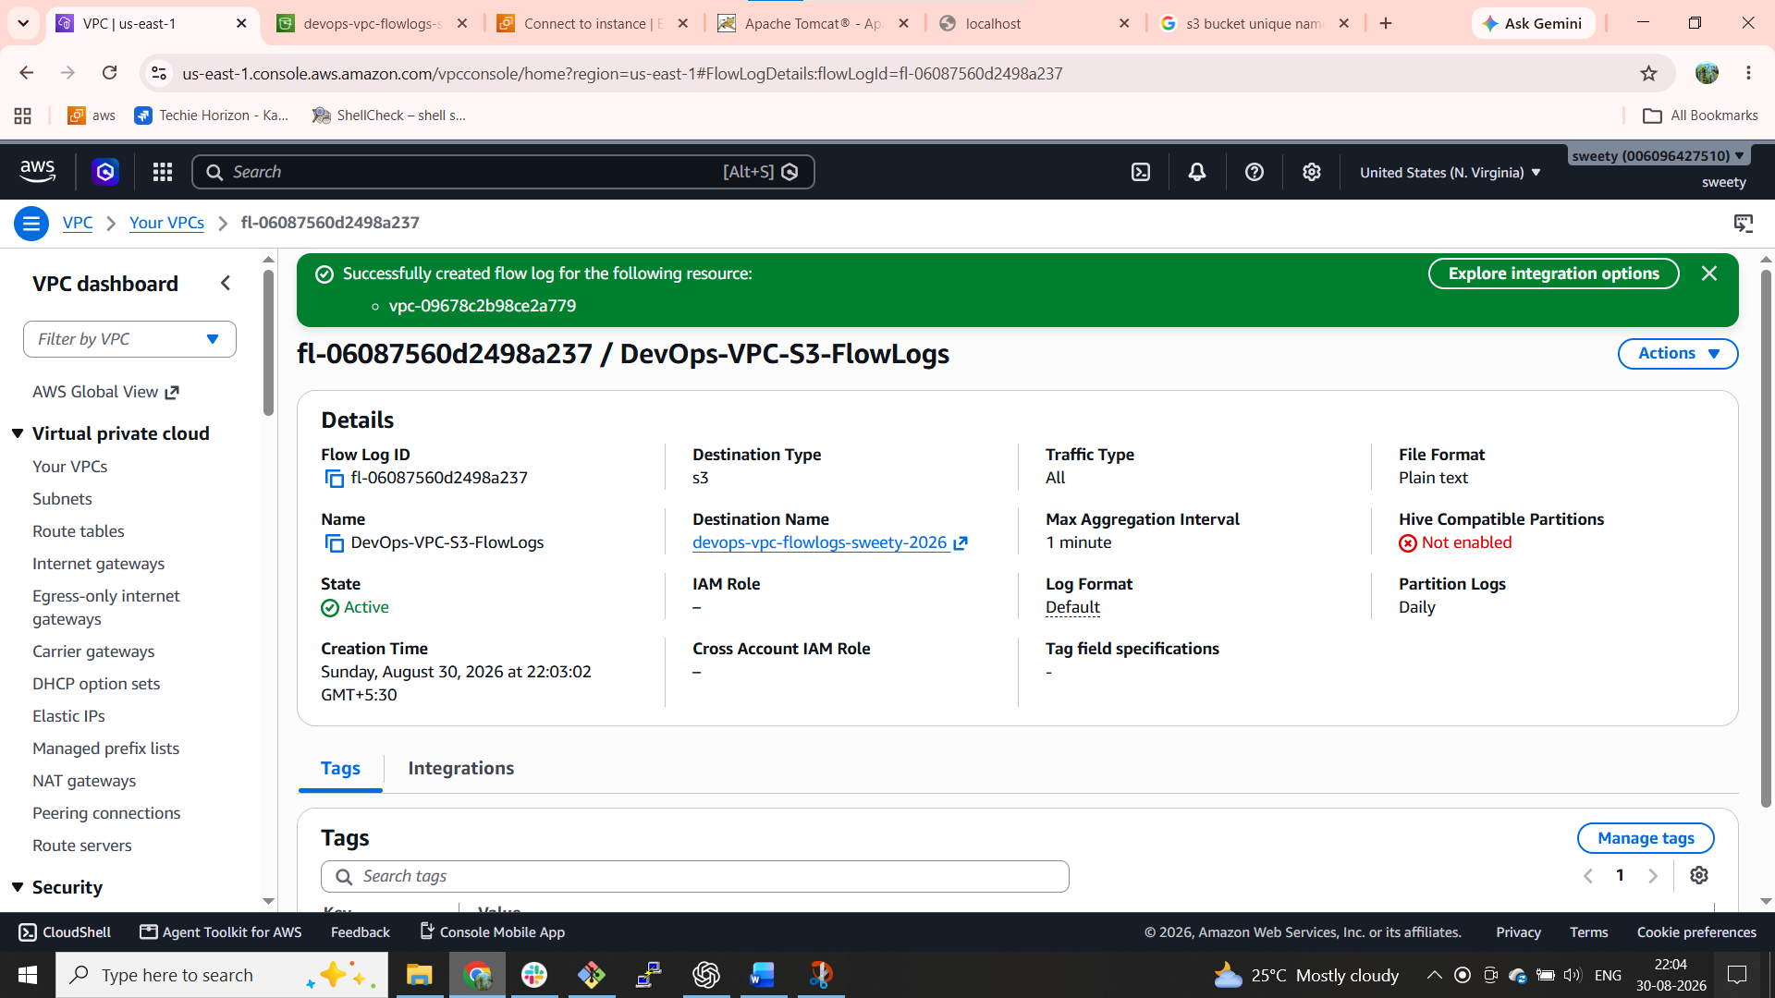
Part B — Flow Logs to CloudWatch
Go back to: VPC → Your VPC → Flow logs
Click: Create flow log
Use:
DevOps-VPC-CloudWatch-FlowLogs
Filter:
All
Aggregation:
1 minute
Destination:
Send to CloudWatch Logs
Create/select a CloudWatch log group
/aws/vpc/DevOps-VPC-FlowLogs

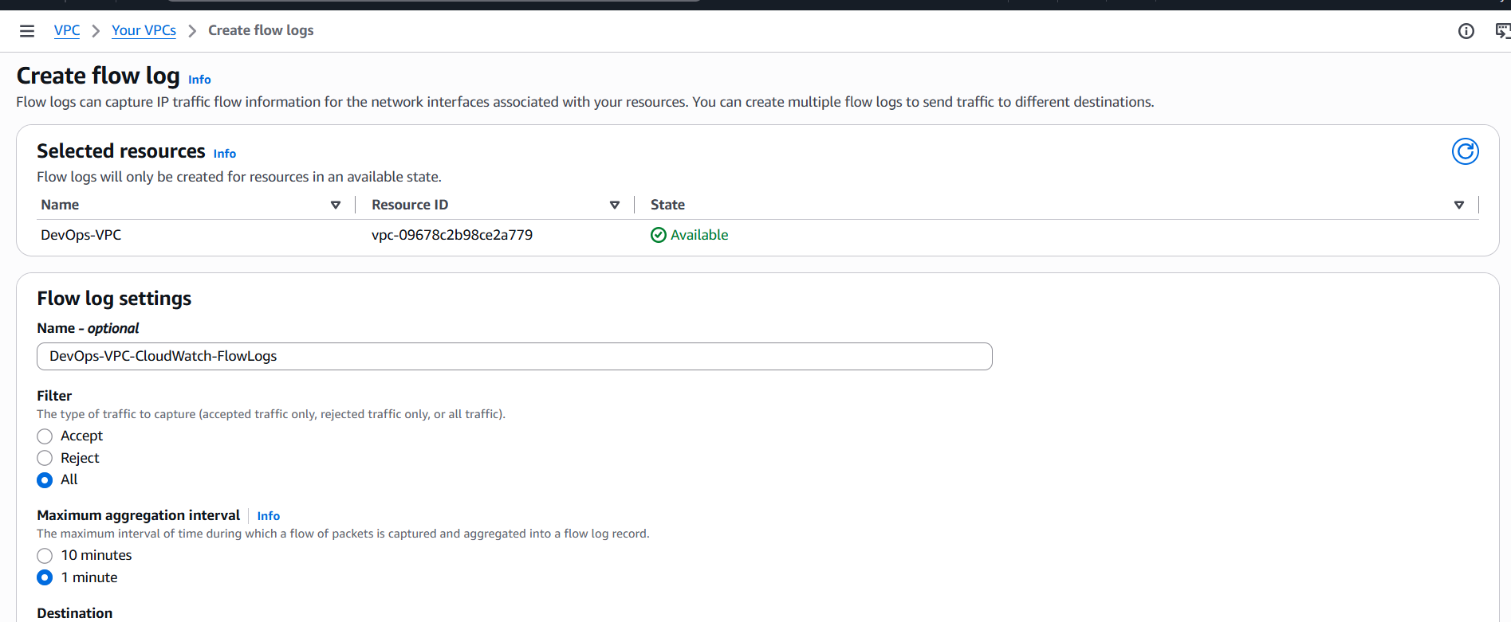
Generate some traffic
To make flow logs appear, generate traffic.
From the public EC2:

curl https://www.google.com
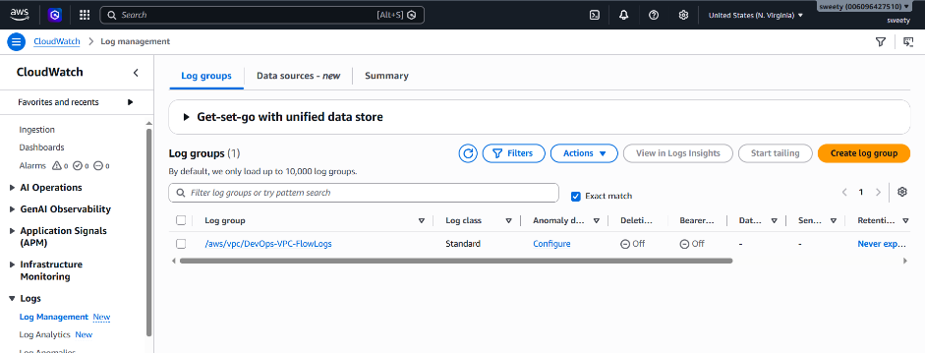

Check CloudWatch
Go to:
AWS Console → CloudWatch
Then:
Logs → Log groups
Open:
/aws/vpc/DevOps-VPC-FlowLogs

